## DP Map

## Interactive Design Requirements Specification

Version: 3.0

Date: 10/06/2018

Presented by: DP Map Team

|  |  |
| --- | --- |
| Team Member 1’s Name | Nathan Cramer |
| Team Member 2’s Name | Pierson Beckman |
| Team Member 3’s Name | Manuel Harvey |
| Team Member 4’s Name | Cameron Faubion |

# Revision History:

* 09/10/2018 Revision 1.0 - System concept and interview questions.
* 09/13/2018 Revision 1.1 - Work Roles and Usability requirements.
* 09/15/2018 Revision 1.2 - Functional requirements and survey data.
* 09/20/2018 Revision 2.0 - Heuristic Task Analysis.
* 09/25/2018 Revision 2.1 - HTA final edits.
* 10/06/2018 Revision 3.0 - Wireframes and Storyboard.

# System Concept

*DP Map will be an Android application that allows users to input the room number of their class and get a map identifying the room they need to go to. The app will cover UNT’s Discovery Park campus.*

# Interview/observation Notes

Who: The primary users of this application are freshman and transfer students who may be unfamiliar with the campus.

Interview questions:

-How often would this app be useful to you?

-Would you prefer to add all your classes at once, or add your classes individually?

-How would we best indicate the location of your class?

-Would it be useful to highlight the path to your class?

-How do you get to school?

-On a scale of 1-5 how technically savvy would you rate yourself?

-What is your grade classification?

-Do you use any other apps for a similar purpose?

-Are you a transfer student?

-Would an app like this be useful to you?

-What is your age/background?

Observation Notes:

We used a google survey to collect information about our users. These are their responses. 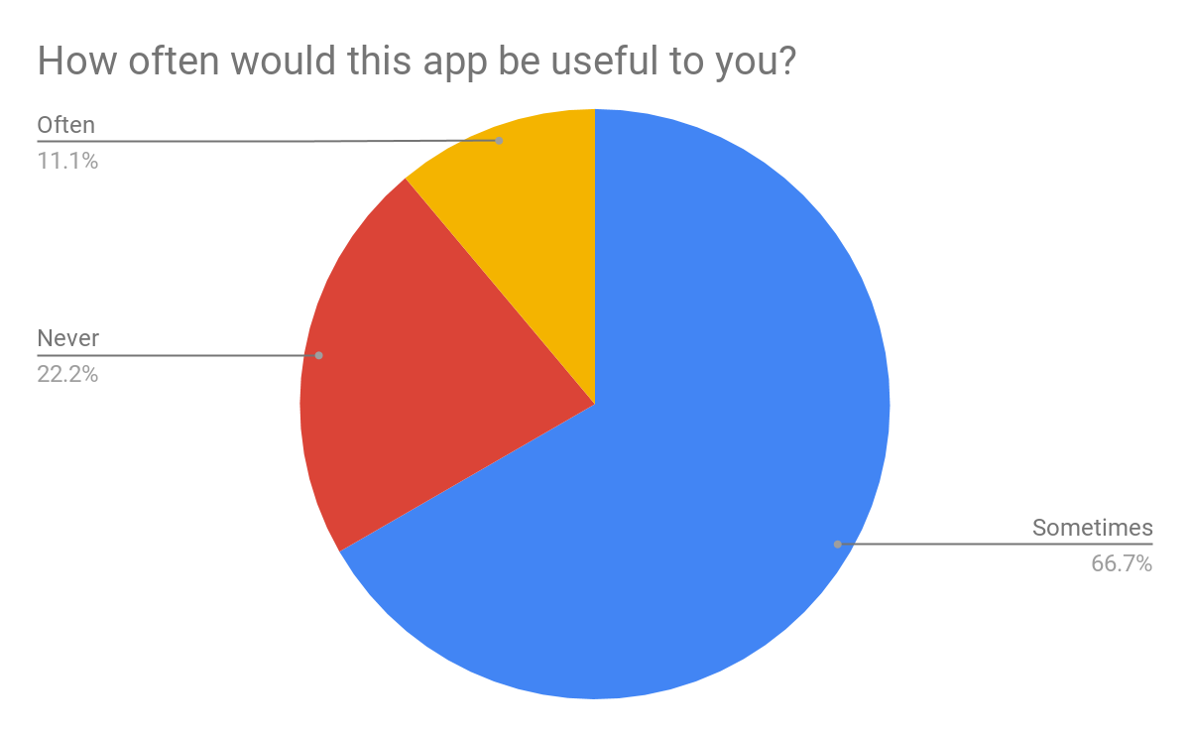

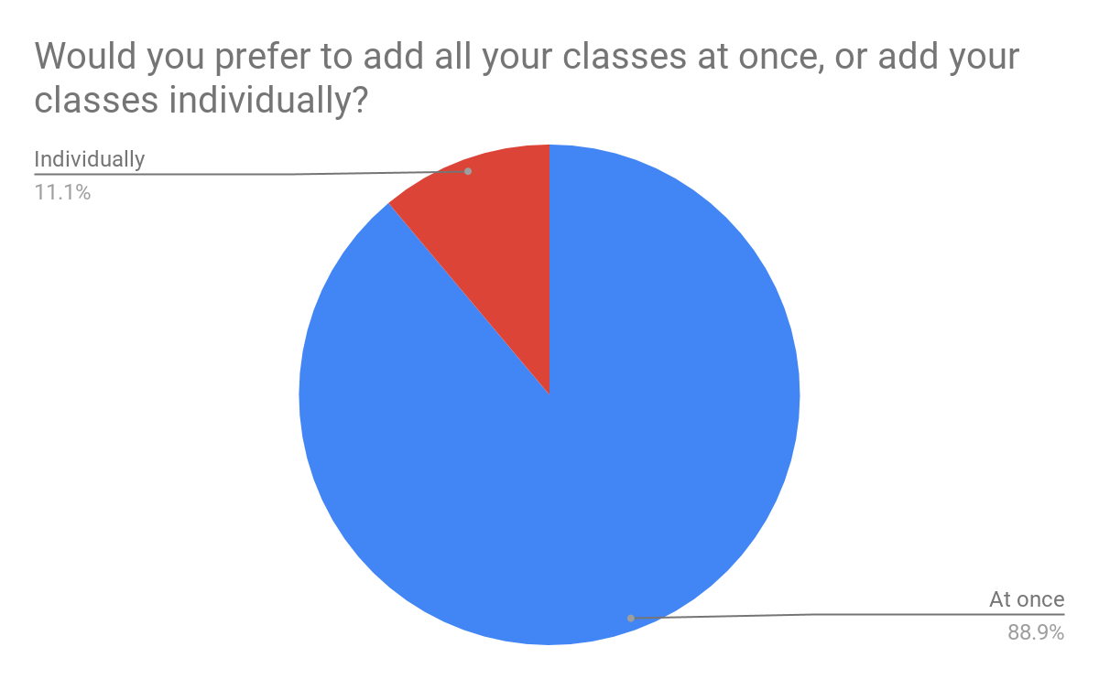

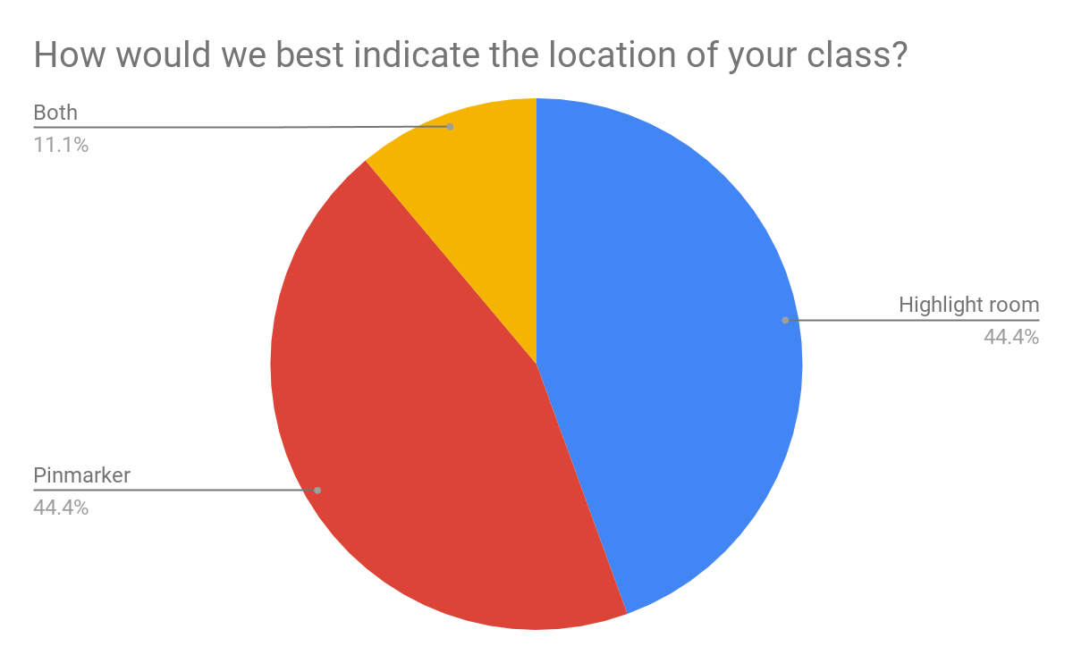

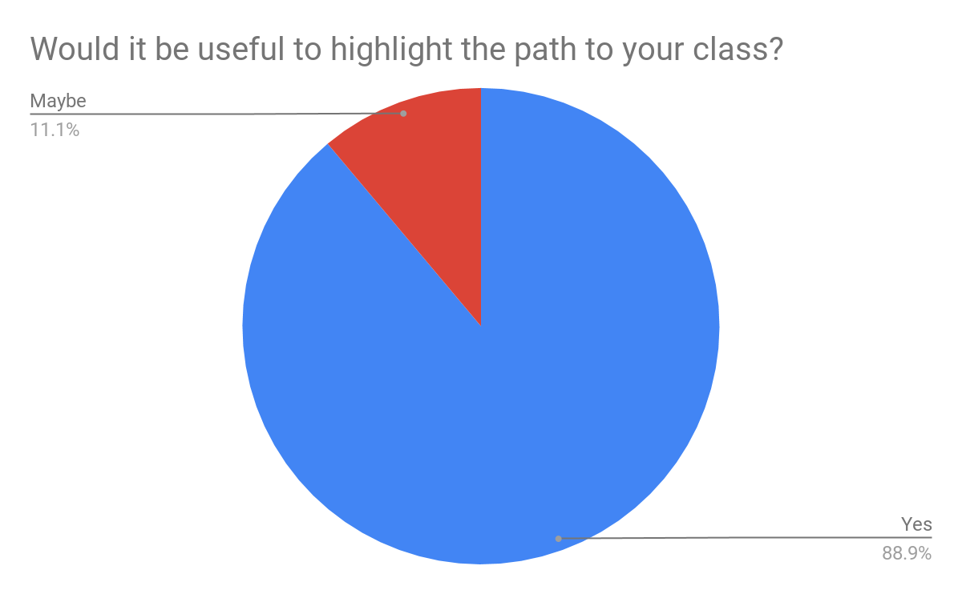

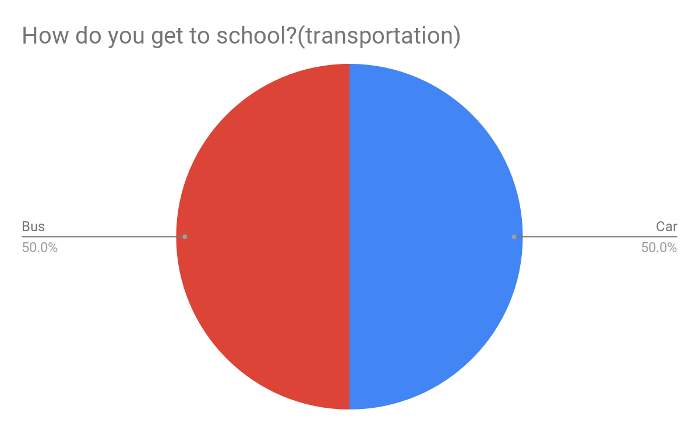

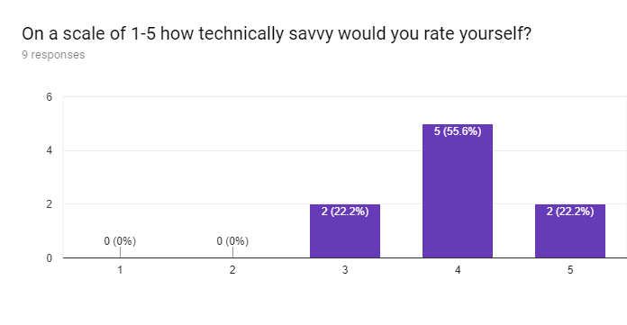

# What is your grade classification?

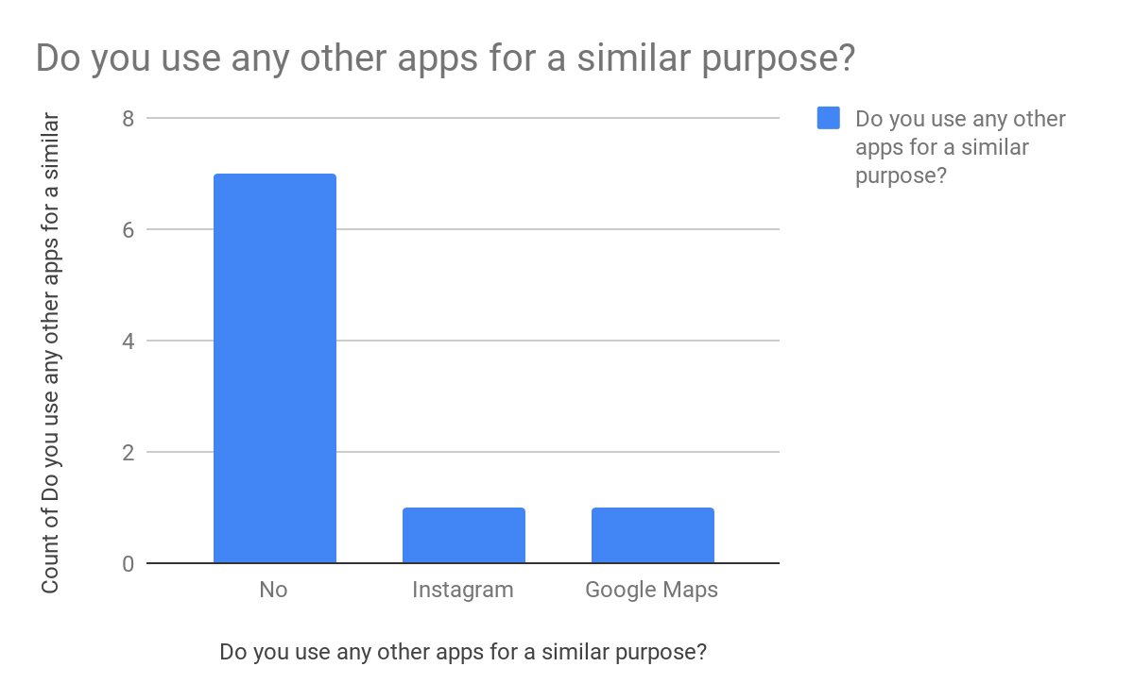

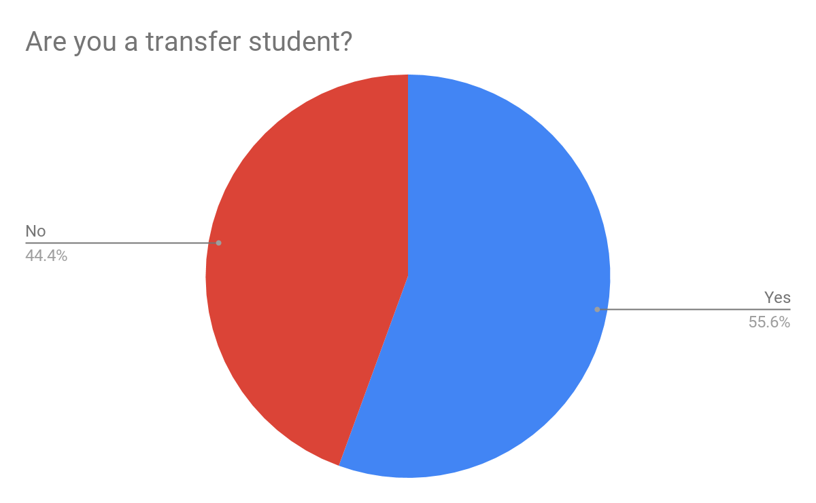

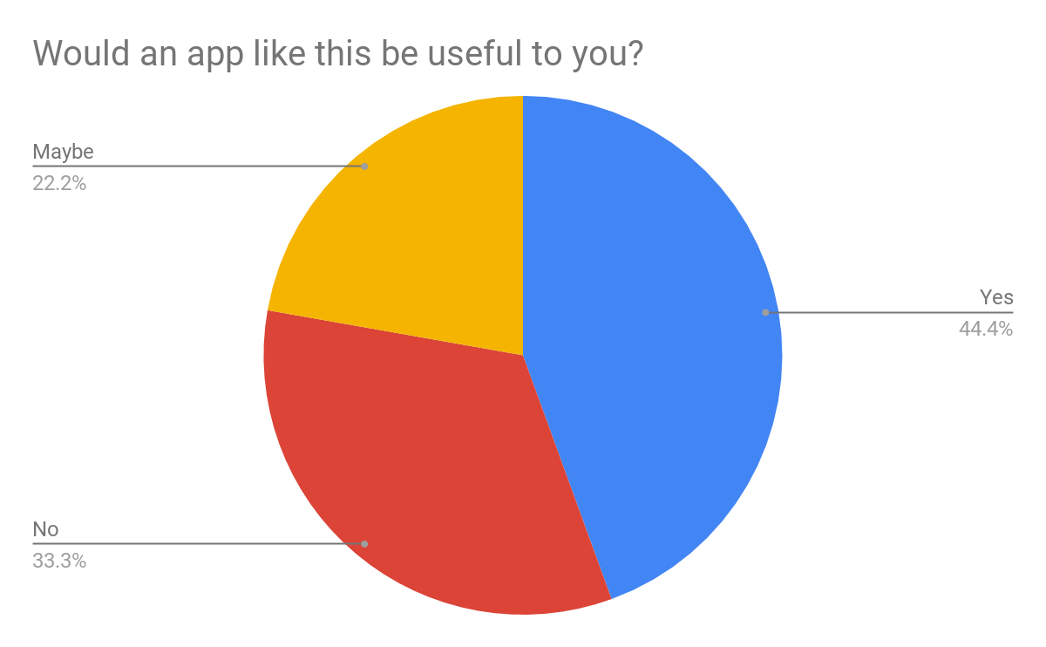

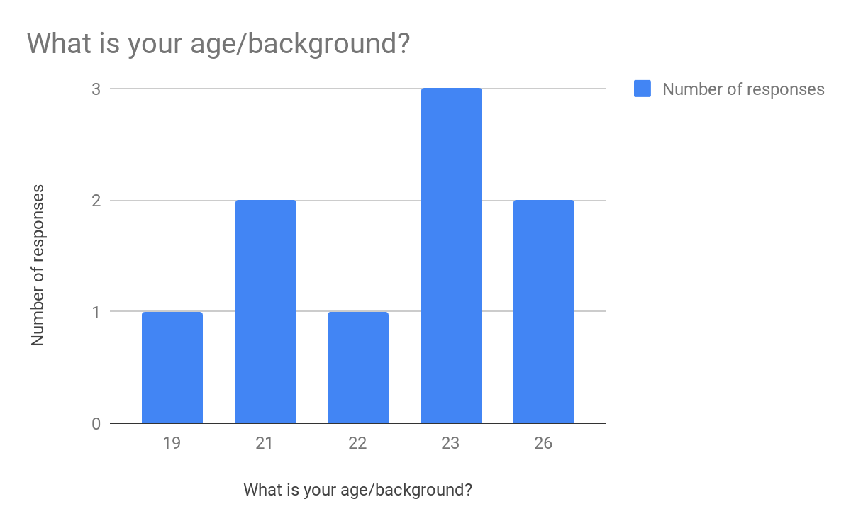

# Work Roles

|  |  |
| --- | --- |
| **Work Role: Freshman or Transfer Student** |  |
| Context of use | Used to find their classes. |
| Goals | Want to find their classes, but the existing apps only help them find the building. |
| Frequency of use | Used to find their classes during the first week of class. |
| Work responsibilities | The user would upload their class room numbers. |
| Work environment | At school, or at home. |
| Abilities | Literate in English. Familiar with using apps on a phone. |
| Personal | 18-30-year-old college student. |

# Functional Requirements

**Primary:**

1: The system shall allow the user to select a room number.

2: The system shall be able to display the selected room on a map.

3: The system shall be able to indicate to the user the selected room on the map.

**Secondary:**(Not a primary concern)

1: The system shall show the optimal path way between classes

# Usability Requirements

UR1: The system shall be learnable in five minutes or less by adults of college age.

UR2: The system shall be usable with one or two hands.

UR3: The system shall support both left-handed and right-handed use.  
UR4: The system shall follow UI guidelines for Android applications.

# 6. Design Modeling - Task Analysis

Feature 1: Add class

0. To add classes to the list.

1. click ‘add class’ button.
2. select class block. (i.e. CSE department block would be ‘F’)
3. input the specific class number. (i.e. 218)
4. click “save class” button.
5. click “yes” or “no” when prompted to add another class.

Plan 0: Do steps 1,2,3,4, and 5 to add a class. repeat until the desired classes show up in the list.

Feature 2: Remove class

0. To remove classes from the list.

1.click ‘remove class’ button.  
 2.select a class from the list of saved classes.  
 3. click ‘yes’ when prompted “are you sure you want to remove this class?”

Plan 0: Do steps 1, 2, and 3 and repeat as necessary to remove the the desired classes.

Feature 3: Choose options

0. To choose options  
 1. click the “options” button  
 2. click “change style”  
 2.1. choose between “pin” and “highlight” for the classes  
 2.2. click “ok” to confirm changes

3. click “choose display mode”  
 3.1. select between “all classes” and “single class”

3.2 click “ok” to apply

Plan 0: Do steps 1, 2, 3, and 4

Plan 2: Do steps 2.1 and 2.2 to select the desired style for indicating classes.

Plan 3: Do steps 3.1 and 3.2 to select the desired display mode.

Feature 4: Locate class

0. To view the class(es) on a map  
 1. click on the “map” button  
 2. (optional) if ‘single class’ mode is selected, pick a class from the drop-down menu

3. look at the map and find your class

Plan 0: Do steps 1, 2, and 3 if the single class view is selected, or steps 1 and 3 if multi class view is selected.

# 7. Conceptual and Intermediate Design

**7.1 Sketches and Storyboards**

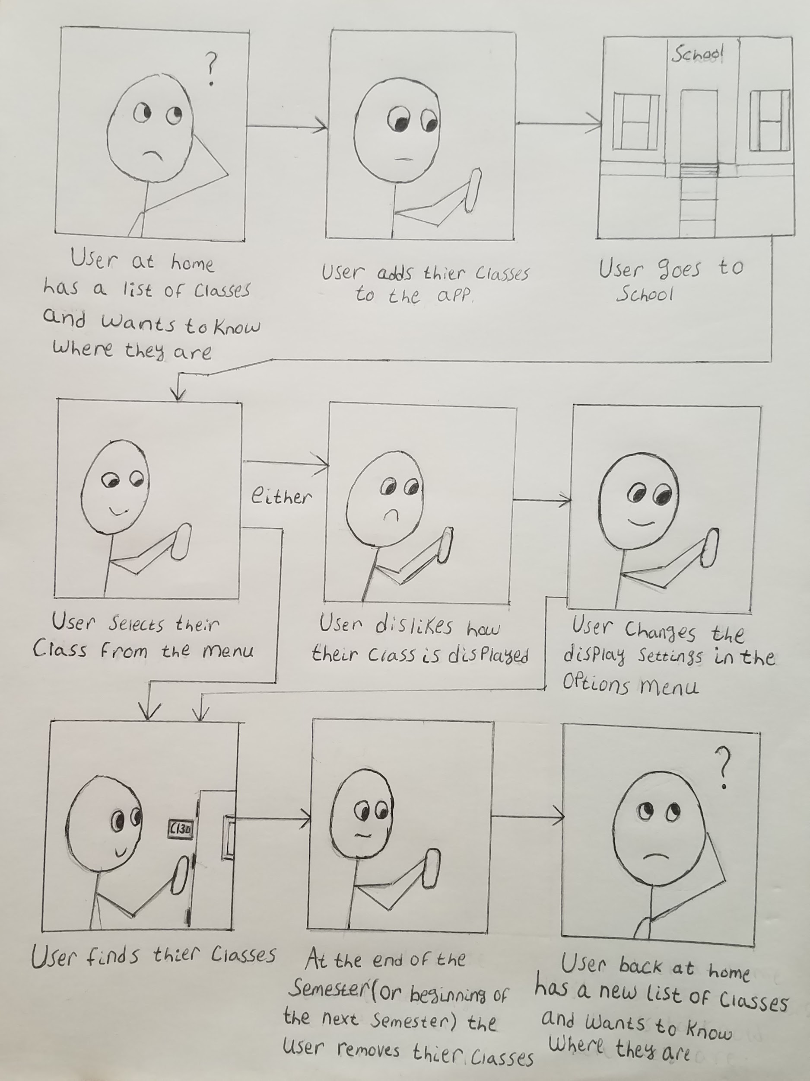

## 

## 

## 

## 

## 

## 

## 

## 

## 7.2 Wireframes

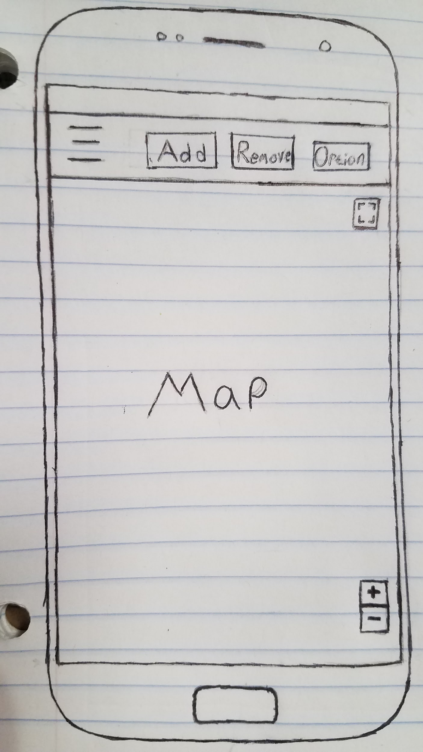

← This is the Wireframe for the main page of the app. The user will see this page when they start up the app.

The three horizontal lines will act as a dropdown menu for a toolbar that contains their list of classes. in the toolbar, the user will be able to select a class to highlight or pin its location on the map.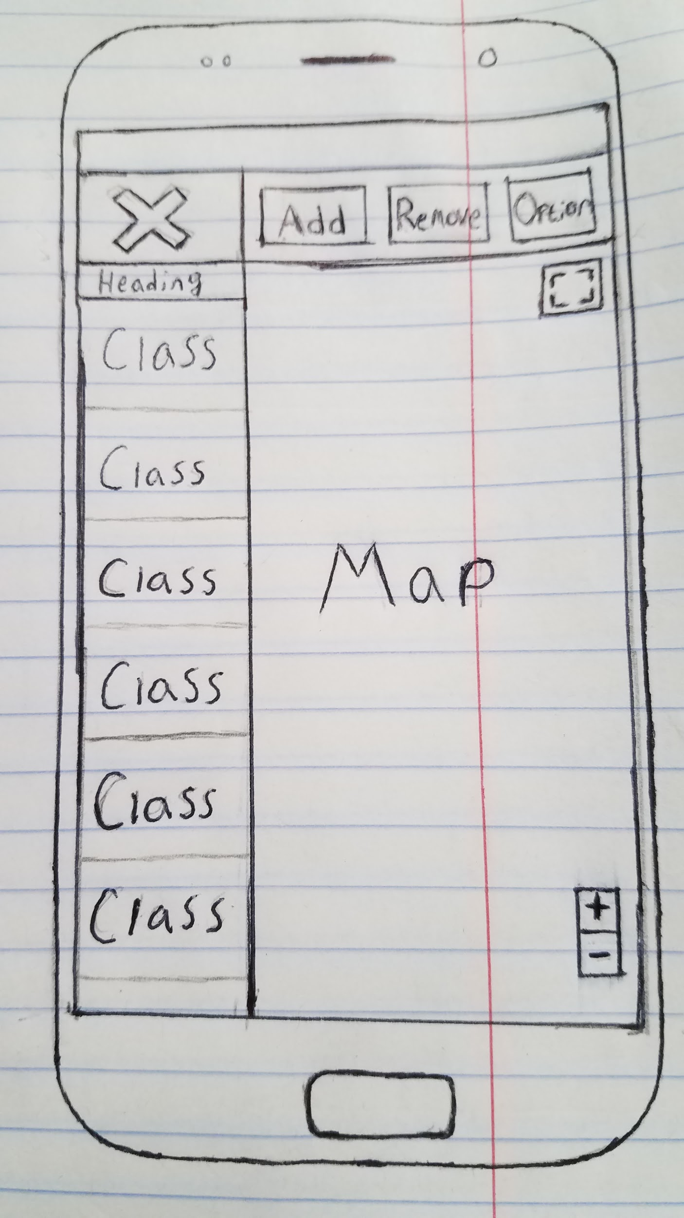

The image on the right shows what this toolbar will look like.

The little buttons on the right side of the map box are optional and will be added to support zoom functions or full screen support if they are deemed necessary in later iterations of development.